# Overview

The purpose of this lab is to become familiar with users, profiles, privileges and roles. This is based on the information in Chapter 8 – User Management.

## Contents

* + Part 1 - User Management

## Due Date:

The lab is due no later than Friday Nov 3rd. You must **hand in** PDF of your work to the dropbox on D2L.

Scoring:   
Lab is worth 30 marks.

# Part 1 – User Management

The following lab is to be completed using SQL Developer, SQL*Plus, and the XE edition of Oracle with the SYS account. You will not be able to complete this lab work on the babbage server because your babbage accounts have student profiles.

1. Create a new user called **New_User** with a password set to **New_Password**. Include the SQL and the results below. *(1 Mark)*

|  |
| --- |
| **CREATE USER New_User**  **IDENTIFIED BY New_Password;**  **User NEW_USER created.**  **HAND IN** |

2. Login into SQL*Plus with **New_User**. Indicate below what happens. *(1 Mark)*

|  |
| --- |
| **Enter user-name: New_User**  **Enter password:**  **ERROR:**  **ORA-01045: user NEW_USER lacks CREATE SESSION privilege; logon denied**  **HAND IN** |

3. Grant the **New_User** the **CONNECT** role. Login as **New_User** and attempt each of the following. If any of them fails, explain why. *(3 Marks)*

1. Can you do a **describe** of **DUAL**?
2. Can you do a **SELECT \*** from **DUAL**?
3. Can you do a **CREATE TABLE TEST AS SELECT * FROM DUAL**;

|  |
| --- |
| **1.** **DESCRIBE dual;**  **HAND IN**  **Name Null? Type**  **----------------------------------------- -------- ----------------------------**  **DUMMY VARCHAR2(1)** |
| **2. SELECT * FROM dual;**  **D**  **-**  **X** |
| 3. **GRANT connect TO New_User;**  **Grant succeeded.**  **CREATE TABLE test AS select * from dual;**    **ERROR at line 1:**  **ORA-01031: insufficient privileges**  **The connect role only allows the CREATE SESSION privilege.** |

4. Grant the **New_User** the **RESOURCE** role. Login as **New_User** and attempt to create the TEST table from question 3.3. What happens this time and why? What privileges does the RESOURCE role have? *(4 Marks)*

|  |
| --- |
| **GRANT resource TO New_User;**  **Grant succeeded.**  **CREATE TABLE test AS select * from dual;**  **\***  **Table created.**  **The table test is created because resource role gives the ability to create objects. CREATE CLUSTER, PROCEDURE, SEQUENCE, TABLE, TRIGGER** |

5. Create a PROFILE called **TEMP_USER**. For this profile make the password expiry equal to 5 and the login attempts equal to 1. Include your SQL below. *(1 mark)*

**HAND IN**

|  |
| --- |
| **CREATE PROFILE TEMP_USER LIMIT**  **FAILED_LOGIN_ATTEMPTS 1**  **PASSWORD_REUSE_MAX 5;**  **Profile TEMP_USER created.** |

6. Display all the information on the new **TEMP_USER** profile. Include below this text the SQL you used to display that information **and** a screenshot of the results. Hint: use one of the **DBA_** views. *(2 Marks)*

**HAND IN**

|  |
| --- |
| **SELECT * FROM DBA_PROFILES**  **WHERE PROFILE = 'TEMP_USER';** |

**HAND IN**

|  |
| --- |
|  |

8. Assign the **Temp_User** profile to **New_User**, show your SQL and the results below. *(1 Mark)*

|  |
| --- |
| **ALTER USER New_User**  **HAND IN**  **PROFILE TEMP_USER;**  **User NEW_USER altered.** |

9. Log into SQL*Plus as **New_User** and this time enter an incorrect password. Attempt to login again with the correct password for **New_User**. What happens? Include your results below. *(1 Mark)*

|  |
| --- |
| **Enter user-name: New_User**  **Enter password:**  **ERROR:**  **ORA-01017: invalid username/password; logon denied**  **Enter user-name: New_User**  **Enter password:**  **ERROR:**  **ORA-28000: the account is locked**  **HAND IN**  **The account is locked after one unsuccessful attempt as specified in the profile.** |

10. Using one of the pop-up windows in SQL Developer, unlock the **New_User** account. Include the screen shot below. *(2 Marks)*

|  |
| --- |
| **HAND IN** |

11. Create another account called **User_2** with password **Password_2** and grant it the **CONNECT** role.

Connect as **User_2** and attempt to select from the **New_User.Test** table. What happens?

Grant **User_2** select privilege to the **New_User.Test** table. Then retry the select, what happens?

Include your results below. What role did we **not** have to give **User_2** that we gave **New_User**? *(4 Marks)*

|  |
| --- |
| **CREATE USER User_2**  **IDENTIFIED BY Password_2;**  **GRANT connect TO User_2;**  **User USER_2 created.**  **Grant succeeded.**  **HAND IN** |
| **SELECT * FROM New_User.Test;**  **ERROR at line 1:**  **ORA-00942: table or view does not exist** |
| **GRANT SELECT ON NEW_USER.TEST TO User_2**  **Grant succeeded.**  **SELECT * FROM New_User.Test;**  **D**  **-**  **X**  **We did not need to assign the resource role to user_2. This ensure the data can be viewed but remain unchanged by other users.** |

12. Step 6 of DBCA (see below) shows the option of using either the same or different administrative passwords for all of SYS, SYSTEM, etc. What would you consider to be the advantages and disadvantages of both of these approaches? *(4 Marks)*

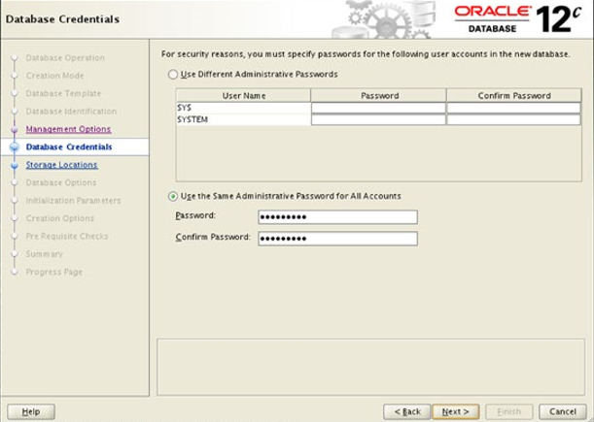

|  |  |  |
| --- | --- | --- |
| **HAND IN** | **Advantages** | **Disadvantages** |
| **Same pw** | **- easily connect/swap to either schema when needed**  **- better flow when preforming administrative tasks** | **- less secure**  **- could potentially log into wrong account**  **- make changes to the wrong account which could be devastating** |
| **Different pw** | **- more secure**  **- less likely to alter wrong schema**  **- easy to distinguish which account you are using for changes** | **- longer time to login**  **- potentially forget either password and have to reset** |

13. In most business systems, security roles are designed to provide an appropriate separation of responsibility and authority. Suppose you are the DBA responsible for the database behind D2L. Consider at least **three** roles that you might be implementing. Describe the functionality (not code) for each role and why you would need them. *(6 Marks)*

|  |  |
| --- | --- |
| **Roles Name**  **HAND IN** | **Role Functionality** |
| **administrative** | **Full access to system create / update / maintain all programs / users** |
| **department chair** | **Few limitations to system maintain / update permissions for faculty for specified department** |
| **instructors** | **More restricted access views specific to courses / program taught update / maintain student records** |
| **student** | **Restricted access / view only for course content and related pages** |